

DEPARTMENT OF COMPUTER SCIENCE AND ENGINEERING

Academic Year
2023 – 2024 (Odd Semester)

MINI PROJECT REPORT

R19CS202 Database Management Systems
R19CS203 Object-Oriented Programming

HOTEL RESERVATION SYSTEM

Submitted by, Mentored by,
[22EC032] | Giritharan A
[22EC056] | Karna M
[22EC047] | Inba Arun Raj D
Ms.J.Sreemathy
Assistant Professor,
Department of CSE

 | TABLE OF CONTENTS
CHAPTER NO. | TITLE |  |  |  | PAGE NO.
 | ABSTRACT |  |  |  | i
 | LIST OF TABLES |  |  |  | ii
 | LIST OF FIGURES |  |  |  | iii
1 | INTRODUCTION
 | 1.1 |  | OBJECTIVES
 | 1.2 |  | SCOPE OF THE PROJECT
2 | SYSTEM ANALYSIS AND SPECIFICATION
 | 2.1 |  | PROBLEM DESCRIPTION
 | 2.2 |  | FUNCTIONAL REQUIREMENT -  HARDWARE & SOFTWARE
 | 2.3 |  | NON – FUNCTIONAL REQUIREMENT
3 | SYSTEM DESIGN
 | 3.1 |  | ER DIAGRAM
 | 3.2 |  | SCHEMA DIAGRAM
4 | PROPOSED SOLUTION
 | 4.1 OVERVIEW |  | USER INTERFACE DESIGN
 | 4.2 |  | CLASS CONSTRUCTION
 | 4.3 |  | DATABASE CREATION
5 |  | PROJECT DESCRIPTION
 |  | 5.1 |  | <<MODULE DESCRIPTION – Use your own Module Name>>
 |  |  |  | <<Add your module Description numbered like 5.1.1, 5.1.2, 5.1.3, etc >>
 |  | 5.2 |  | JDBC CONNECTIVITY
6 |  | IMPLEMENTATION
7 |  | RESULTS AND DISCUSSION
8 |  | CONCLUSION & FUTURE ENHANCEMENT
9 |  | REFERENCES

ABSTRACT

The JavaFX and SQL Hotel Management System is a unified application meticulously crafted to streamline the multifaceted tasks faced by hotel staff, encompassing room bookings, guest information management, and billing processes. This single-page application is thoughtfully structured, incorporating billing and payment processes, room details management, and comprehensive guest information tracking. The user-friendly interface, dynamically powered by JavaFX, ensures a fluid and intuitive navigation experience between the various modules.
At its core, the system is tailored to meet the specific needs of hotel staff, providing a seamless and efficient solution for room reservations, personalized guest services, and secure financial transactions. The integration of SQL as the underlying database technology ensures robust data storage and retrieval mechanisms, contributing significantly to the reliability and effectiveness of the hotel management experience facilitated by this application.
In essence, the JavaFX and SQL Hotel Management System stands as a testament to the harmonious fusion of technology and functionality. Through its single-page design, it not only simplifies complex hotel management processes but also enriches the user experience by offering an interface that is both intuitive and visually engaging. The system, with its comprehensive feature set and thoughtful integration of JavaFX and SQL, emerges as a powerful tool for hotel staff, delivering a holistic solution for efficient hotel operations and guest services.

CHAPTER 1
INTRODUCTION
  - OBJECTIVES
The objective of the Hotel Management System is to provide a comprehensive application for efficiently managing hotel room bookings, guest details, billing, and reservations. The application is designed to meet the specific needs of hotel staff, ensuring seamless operations and enhanced guest services.

  - SCOPE OF THE PROJECT
Hotel Reservation System is basically updating the manual Hotel system into an internet-based application so that the users can know the details of their accounts, availability of rooms and type of the rooms.
The project is specifically designed for the use of Hotel Management ,Staffs and users. The product will work as a complete user interface for Hotel Reservation process and Hotel usage from users. Hotel Reservation System can be used by any existing or new Hotel to manage its rooms and check in and check out status.
The project can be easily implemented under various situations. We can add new features as and when we require.
The language used for developing the project is Java as it is quite advantageous than other languages in terms of performance, tools available, cross platform compatibility, cost (freely available), and development process.

CHAPTER 2
SYSTEM ANALYSIS AND SPECIFICATION

2.1 PROBLEM DESCRIPTION
The current hotel management system lacks an integrated and efficient solution for managing room bookings, guest details, and billing processes. Hotel staff face challenges in organizing and streamlining reservations, resulting in potential inefficiencies and delays. The absence of a centralized system leads to difficulties in managing billing and payment processes accurately. Additionally, the manual handling of guest information is prone to errors and may compromise the quality of personalized services.

2.2 FUNCTIONAL REQUIREMENT –
SOFTWARE AND HARDWARE REQUIREMENT
INTELJI
MYSQL COMMAND LINE
2.3 NON FUNCTIONAL REQUIREMENT
- Performance
- Reliability
- Security
- Usability
- Scalability
- Maintainability
- Compatibility

CHAPTER 3
SYSTEM DESIGN
3.1 ER DIAGRAM
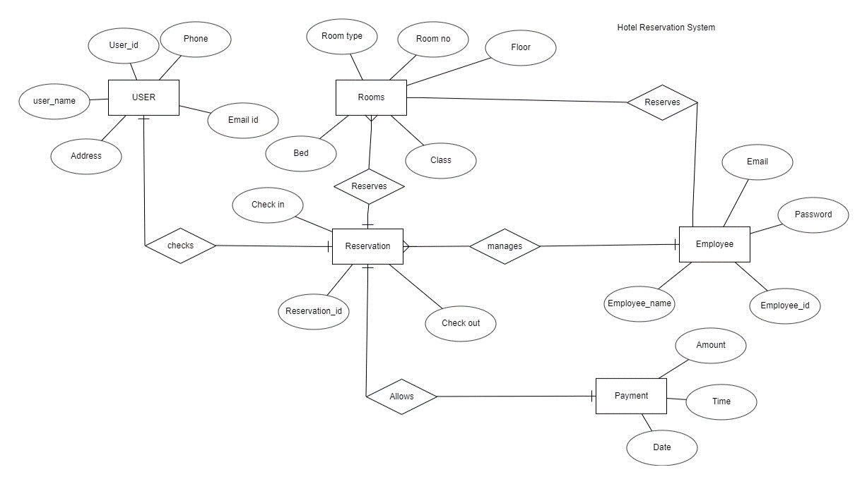3.2 SCHEMA DIAGRAM
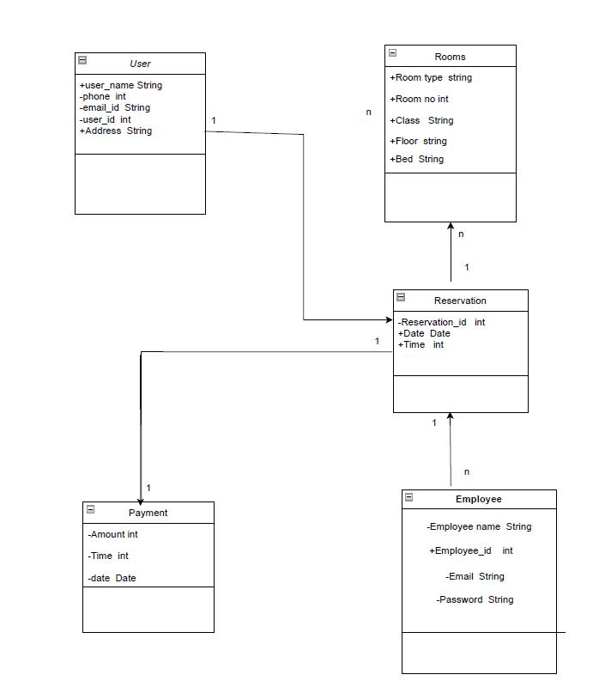
CHAPTER 4
PROPOSED SOLUTION

4.1 USER INTERFACE DESIGN
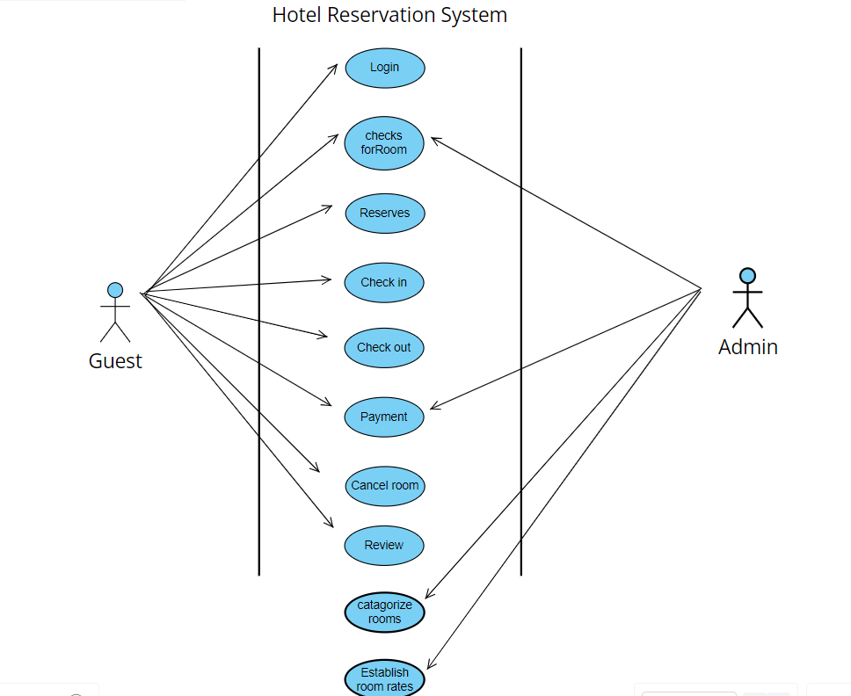

4.2 CLASS CONSTRUCTION
// Class representing the main application
package com.example.hotelreservationsystem;

import javafx.application.Application;
import javafx.fxml.FXMLLoader;
import javafx.scene.Scene;
import javafx.stage.Stage;

import java.io.IOException;

public class HelloApplication extends Application {
@Override
public void start(Stage stage) throws IOException {
FXMLLoader fxmlLoader = new FXMLLoader(HelloApplication.class.getResource("hello-view.fxml"));
Scene scene = new Scene(fxmlLoader.load(), 420, 240);
stage.setTitle("Login page!");
stage.setScene(scene);
stage.show();
}
public static void main(String[] args) {
launch();
}
}
4.3 DATABASE CREATION

Create database Tables_in_hotel;;
Create table loginpage;
Insert into loginpage(username,password)values(‘Giri’,’karna’);

CHAPTER 5
PROJECT DESCRIPTION

5.1 MODULE DESCRIPTION
5.1.1 GUI Module
- Responsibility: Manages the graphical user interface using JavaFX.
- Classes: WeatherAppGUI (JavaFX application), WeatherController (handles UI events), SceneBuilder (creates UI components).

5.1.2 Data Module
- Responsibility: Deals with data-related operations, including fetching and storing weather data.
- Classes: WeatherDatabase (interacts with the database), WeatherData (represents the model for weather information).

5.1.3Authentication Module
- Responsibility: Manages user authentication and authorization.
- Classes: UserAuthenticator (handles user authentication), AccessControlManager (manages access control based on user roles).

5.1.4 Main Application Module
- Responsibility: Serves as the entry point for the application.
- Classes: WeatherApp (main class to launch the application).

5.1.5 Utility Module
- Responsibility: Contains utility classes and methods used across different modules.
- Classes: DateUtils (for date-related operations), ErrorHandler (handles application errors).

5.1.6 Test Module
- Responsibility: Includes unit tests and integration tests for various components.
- Classes: WeatherControllerTest, WeatherDatabaseTest, UserAuthenticatorTest (example test classes).

5.2 JDBC CONNECTIVITY:
import java.sql.Connection;
import java.sql.DriverManager;
import java.sql.SQLException;
public class HelloController {
private static final String DATABASE_URL = "jdbc:mysql://localhost:3306/hotel";
private static final String USERNAME = "root
private static final String PASSWORD = "Giritharan@123";
CHAPTER 6
IMPLEMENTATION
//Contoller.java
package com.example.hotelreservationsystem
import javafx.event.ActionEvent;
import javafx.fxml.FXML;
import javafx.scene.control.*;
import java.sql.*;
import java.io.IOException;
import java.util.EventObject;
import javafx.fxml.FXMLLoader;
import javafx.scene.Node;
import javafx.scene.Parent;
import javafx.scene.Scene;
import javafx.stage.Stage;
import javafx.scene.input.MouseEvent;
import javafx.scene.image.ImageView;
import javafx.scene.control.Button;
import javafx.scene.control.DatePicker;
import javafx.scene.control.TextField;
import java.time.*;
public class HelloController {
private static final String DATABASE_URL = "jdbc:mysql://localhost:3306/hotel";

private static final String USERNAME = "root";
private static final String PASSWORD = "Giritharan@123";
@FXML
private TextField usernameField;
@FXML
private PasswordField passwordField;
PreparedStatement pst;
@FXML
private Label Welcometext;
@FXML
private Stage stage;
@FXML
private Scene scene;
@FXML
private DatePicker CheckinTextField;
@FXML
private DatePicker CheckoutTextField;
@FXML
private TextField RoomtypeTextField;
@FXML
private TextField TotalguestTextField;
@FXML
private Button checkButton;
@FXML
private ImageView imageview;
@FXML
private TextField AddressTextField;
@FXML
private TextField Phonenumber;
@FXML
private TextField RoomtypeText;
@FXML
private Button complete;
@FXML
private TextField districtTextField;
@FXML
private TextField emailTextField;
@FXML
private TextField nameTextfield;
@FXML
private TextField Name;
@FXML
private TextField addressfield;
@FXML
private TextField districtfield;
@FXML
private TextField emailfield;
@FXML
private TextField namefield;
@FXML
private TextField personsfield;
@FXML
private TextField phonenumberfield;
@FXML
private TextField roomtypefield;
@FXML
private void onHelloButtonClick(ActionEvent event) {
if (usernameField != null && passwordField != null) {
String providedUsername = usernameField.getText();
String providedPassword = passwordField.getText();
try (Connection connection = DriverManager.getConnection(DATABASE_URL, USERNAME, PASSWORD)) {
String sql = "SELECT * FROM loginpage WHERE username = ? AND password = ?";
try (PreparedStatement preparedStatement = connection.prepareStatement(sql)) {
preparedStatement.setString(1, providedUsername);
preparedStatement.setString(2, providedPassword);
try (ResultSet resultSet = preparedStatement.executeQuery()) {
if (resultSet.next()) {
Welcometext.setText("Authentication successful!");
RoomScene();

} else {
Welcometext.setText("Invalid username or password.");
}
}
}
} catch (SQLException e) {
e.printStackTrace();
Welcometext.setText("Error: " + e.getMessage());
}
} else {
Welcometext.setText("usernameField or passwordField is null!");
}
}

@FXML
private void RoomScene() {
try {
FXMLLoader loader = new FXMLLoader(getClass().getResource("Roomm.fxml"));
Parent root = loader.load();

Stage stage = new Stage();
stage.setTitle("Selection field");
stage.setScene(new Scene(root));

stage.show();

Stage loginStage = (Stage) usernameField.getScene().getWindow();
loginStage.close();
} catch (IOException e) {
e.printStackTrace();
Welcometext.setText("Error loading room scene: " + e.getMessage());
}
}

@FXML
private void Openuserscene() {
LocalDate newcheckin = CheckinTextField.getValue();
LocalDate newcheckout = CheckoutTextField.getValue();
String newroom = RoomtypeTextField.getText();
String newguest = TotalguestTextField.getText();
try (Connection connection = DriverManager.getConnection(DATABASE_URL, USERNAME, PASSWORD)) {
String sql = "INSERT INTO roomdetail (Checkin, Checkout , Roomtype , Totalguest) VALUES (?, ? , ? , ?)";
try (PreparedStatement preparedStatement = connection.prepareStatement(sql)) {
preparedStatement.setDate(1, Date.valueOf(newcheckin));
preparedStatement.setDate(2, Date.valueOf(newcheckout));
preparedStatement.setString(3, newroom);
preparedStatement.setString(4, newguest);

preparedStatement.executeUpdate();
System.out.print("User room details registered successfully!");
}
} catch (SQLException e) {
e.printStackTrace();
System.out.print("Error!");
}
openu();
}
private void openu() {
try {
FXMLLoader loader = new FXMLLoader(getClass().getResource("Userdetailss.fxml"));
Parent root = loader.load();
Stage stage = new Stage();
stage.setTitle("User Details");
stage.setScene(new Scene(root));
stage.show();
} catch (IOException e) {
e.printStackTrace();
}
}
@FXML
private void userdetailconfirm() {
String newname = Name.getText();
String newemail = emailTextField.getText();
String newaddress = AddressTextField.getText();
String newphonenumber = Phonenumber.getText();
String newroomtype = RoomtypeText.getText();
String newdistrict = districtTextField.getText();
try (Connection connection = DriverManager.getConnection(DATABASE_URL, USERNAME, PASSWORD)) {
String sql = "INSERT INTO userdetail (name, email , address , phonenumber,roomtype,district) VALUES (?, ? , ? , ?, ?, ?)";
try (PreparedStatement preparedStatement = connection.prepareStatement(sql)) {
preparedStatement.setString(1, newname);
preparedStatement.setString(2, newemail);
preparedStatement.setString(3, newaddress);
preparedStatement.setString(4, newphonenumber);
preparedStatement.setString(5, newroomtype);
preparedStatement.setString(6, newdistrict);
preparedStatement.executeUpdate();
System.out.print("User details registered successfully!");
}
} catch (SQLException e) {
e.printStackTrace();
System.out.print("Error!");
}
useru ();
}
public void useru () {
try {
FXMLLoader loader = new FXMLLoader(getClass().getResource("conformation.fxml"));
Parent root = loader.load();
Stage stage = new Stage();
stage.setTitle(" user conformation");
stage.setScene(new Scene(root));
stage.show();
} catch (IOException e) {
e.printStackTrace();
}
}
@FXML
private void paymentdetails() {
String newname = namefield.getText();
String newemail = emailfield.getText();
String newphonenumber = phonenumberfield.getText();
String newaddress = addressfield.getText();
String newdistrict = districtfield.getText();
String newroomtype = roomtypefield.getText();
String newpersons = personsfield.getText();
try (Connection connection = DriverManager.getConnection(DATABASE_URL, USERNAME, PASSWORD)) {
String sql = "INSERT INTO userconfirm (name, email , phonenumber,address,district,roomtype,persons) VALUES (?, ? , ? , ?, ?, ? ,?)";
try (PreparedStatement preparedStatement = connection.prepareStatement(sql)) {
preparedStatement.setString(1, newname);
preparedStatement.setString(2, newemail);
preparedStatement.setString(3, newphonenumber);
preparedStatement.setString(4, newaddress);
preparedStatement.setString(5, newdistrict);
preparedStatement.setString(6, newroomtype);
preparedStatement.setString(7, newpersons);

preparedStatement.executeUpdate();
System.out.print("User details are confirmed successfully!");
}
} catch (SQLException e) {
e.printStackTrace();
System.out.print("Error!");
}
payment();
}
private void payment(){
try {
FXMLLoader loader = new FXMLLoader(getClass().getResource("Payment.fxml"));
Parent root = loader.load();
Stage stage = new Stage();
stage.setTitle("$$payment$$");
stage.setScene(new Scene(root));
stage.show();
} catch (IOException e) {
e.printStackTrace();
}
}
@FXML
private void finaldetails() {
try {
FXMLLoader loader = new FXMLLoader(getClass().getResource("final.fxml"));
Parent root = loader.load();
Stage stage = new Stage();
stage.setTitle("Final ");
stage.setScene(new Scene(root));
stage.show();
} catch (IOException e) {
e.printStackTrace();
}
}
@FXML
private void logindetails() {
try {
FXMLLoader loader = new FXMLLoader(getClass().getResource("hello-view.fxml"));
Parent root = loader.load();
Stage stage = new Stage();
stage.setTitle("login Scene");
stage.setScene(new Scene(root));
stage.show();
} catch (IOException e) {
e.printStackTrace();
}
}
}

CHAPTER 7

RESULTS AND DISCUSSIONS
//For login page
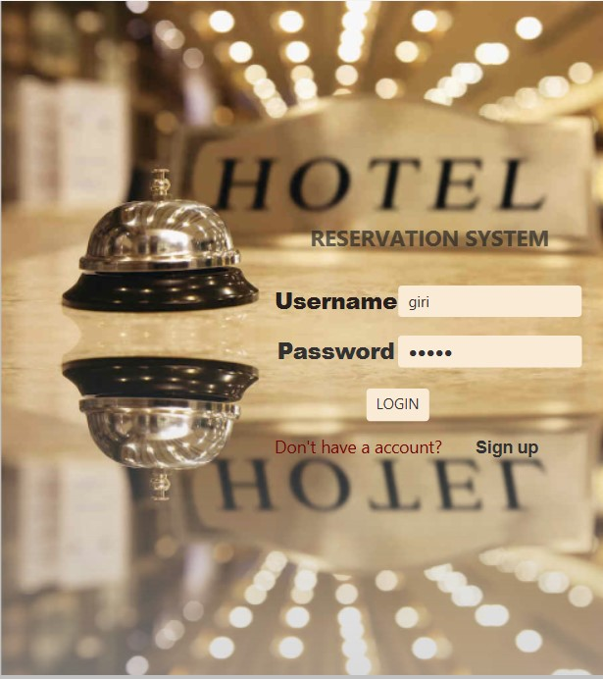
// For Check in and check out time:
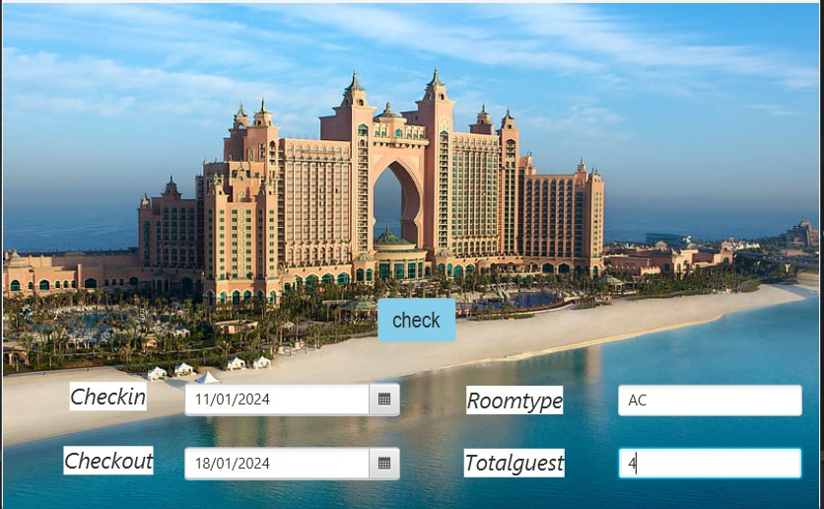
For getting user detail:
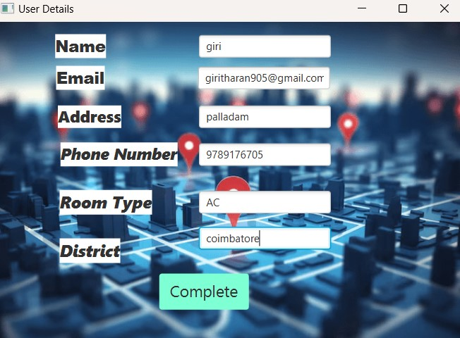

For confirming user detail:
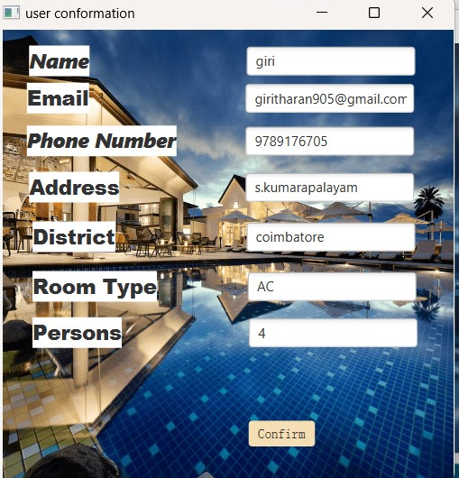

For payment:
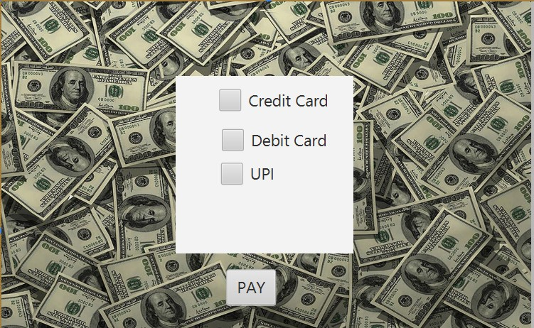

//For final page


CHAPTER 8

CONCLUSION AND FUTURE ENHANCEMENT
In conclusion, the Hotel Management System, designed to address the challenges faced in managing room bookings, guest details, and billing processes, represents a significant leap forward in enhancing operational efficiency and guest satisfaction within the hotel industry. Through a comprehensive approach, this project has successfully tackled key problems such as inefficient billing processes, disorganized room details management, inadequate guest information handling, unmet needs of hotel staff, and poor requirement gathering.
By implementing robust billing and payment processes, streamlining room details management, and improving guest information handling, the new system aims to transform the hotel management experience. The inclusion of user-friendly interfaces, powered by JavaFX, ensures a seamless navigation experience for hotel staff, contributing to improved productivity and reduced learning curves.
The project emphasizes a thorough understanding of the specific needs and workflows of hotel staff, leading to the creation of a tailored solution that aligns with industry requirements. Through effective requirement gathering and feature incorporation, the system is poised to provide a holistic and adaptable platform for hotels of varying sizes and complexities.
The integration of SQL ensures secure and efficient data storage and retrieval, contributing to the reliability and effectiveness of the overall hotel management experience. With a focus on automation, accuracy, and personalized guest services, the project not only addresses existing challenges but also lays the foundation for future scalability and enhancements.
In essence, the Hotel Management System project stands as a testament to the power of technology in revolutionizing the hospitality sector. By providing an integrated solution, the system aims to empower hotel staff, streamline operations, and ultimately elevate the guest experience. The successful implementation of this project promises to contribute significantly to the efficiency and competitiveness of hotels in the dynamic

REFERENCES

[1] https://www.geeksforgeeks.org/design-online-hotel-booking-system-like-oyo-rooms/
[2] https://www.codeproject.com
[3] https://www.sourcecodester.com/visual-basic/hotel-reservation-system.html
[4] https://www.jumeirah.com/en/stay/dubai/burj-al-arab-jumeirah
[5] https://github.com/topics/hotel-reservation-system

